Blockchain-Based IoT Edge Computing System

Engineering Installation & Operation Manual

1. Purpose of This Manual
This document is a technical installation and usage manual, written the way industrial software or field-deployed systems are documented.
It explains:
- Why each technology was selected
- How the system is installed and deployed
- What actually happens under the hood when the system runs
- How data flows from device → edge → blockchain → dashboard
- How to operate, validate, and troubleshoot the system
This is a workthrough manual for reviewers.

2. System Objective
The project demonstrates a secure, decentralized Industrial IoT edge architecture where:
- IoT devices publish data to an edge gateway
- The gateway validates and rate-controls data
- Critical events are immutably logged on a blockchain
- A web dashboard visualizes device state and blockchain confirmations
The core engineering problem addressed:
How do you ensure integrity, traceability, and trust in edge-generated IoT data without relying on a centralized server?

3. High-Level Architecture
Logical Stack
- IoT Edge Devices – ESP32 / Arduino-class MCU
- Message Transport Layer – MQTT Broker (Mosquitto)
- Edge Gateway – Node.js validation & blockchain interface
- Blockchain Layer – Ethereum-compatible local network (Hardhat)
- Smart Contract – Immutable event logging & verification
- Frontend Dashboard – React-based visualization
Each layer is intentionally isolated to reflect real industrial deployment boundaries.

4. Technology Selection & Engineering Rationale

4.1 Microcontroller (ESP32 / Arduino)
Reasoning:
- Sufficient processing for cryptographic hashes
- Native WiFi support
- Widely used in industrial prototyping
- Deterministic firmware behavior
Design Decision: The MCU does not interact directly with the blockchain.
Blockchain interaction is intentionally offloaded to the edge gateway to avoid latency, gas cost exposure, and firmware complexity.

4.2 MQTT (Mosquitto Broker)
Why MQTT:
- Lightweight publish/subscribe model
- Decouples device and backend
- Industry-standard for IIoT
Why Mosquitto:
- Open-source
- Minimal overhead
- Easy local deployment
Operational Logic:
- Devices publish sensor or event payloads
- Gateway subscribes to validated topics
- No direct device-to-dashboard coupling

4.3 Edge Gateway (Node.js)
Role: This is the trust enforcement layer.
Responsibilities:
- MQTT subscription
- Payload validation
- Timestamp normalization
- Nonce-based replay protection
- Rate limiting
- Blockchain transaction orchestration
Why Node.js:
- Strong async I/O for MQTT
- Mature blockchain libraries (ethers.js / web3.js)
- Clean separation of logic layers

4.4 Blockchain Network (Hardhat – Local Ethereum)
Purpose:
- Provide immutable logging
- Demonstrate smart contract interaction
- Avoid dependency on public networks
Why Local Blockchain:
- Zero gas cost
- Deterministic testing
- Full control over accounts and mining
The focus is system trust logic, not public chain deployment.

4.5 Smart Contract
Function:
- Accept validated event data
- Emit on-chain events
- Store hashes / metadata immutably
Key Design Choice: The contract does not store raw sensor data.
Instead, it stores:
- Hashes
- Device IDs
- Timestamps
This mirrors real-world blockchain constraints.

4.6 Frontend Dashboard (React)
Purpose:
- Human-readable visualization
- Event confirmation display
- Blockchain transaction tracking
Design Principle: Frontend is read-only with respect to blockchain state.
All authority remains at the edge gateway.

5. Installation Prerequisites

Software
- Node.js (LTS)
- npm
- Hardhat
- Mosquitto MQTT Broker
- Git

Hardware
- ESP32 or Arduino-compatible board
- WiFi network

6. Repository Structure
/BLOCKCHAIN_BASED_IOT_EDGE
│
├── docs,demo_videos
├── Trust_Layer/ # Deployment scripts
|----contracts/ # Solidity smart contracts
|----sripts/ # Hardhat based Node deployment
|----hardhat.config.js
├── iot-gateway/ # Node.js MQTT + blockchain logic
|----.env # Environment configuration
|----contract-abi.json # ABI generated in trust layer artifacts
|----gateway.js # gateway deployment for IOT and blockchain comm
├── MCU_nodes/ # MCU code
├── web-dashboard/src # React dashboard
|----components #app components
|----utils/
|-------web3Config.js #configuration for dashboard deployment

7. System Installation & Run Procedure (End-to-End)
This section documents the complete operational sequence from Solidity source code to a live React dashboard. Each step explains what is executed, what artifacts are produced, and why the step exists in the system.

Step 1: Clone Repository
git clone <your-repo-url>
cd BLOCKCHAIN_BASED_IOT_EDGE
This retrieves all system layers (contracts, gateway, MCU firmware, and frontend) into a single, version-controlled workspace.

Step 2: Install Node Dependencies (Root & Submodules)
npm install
This installs Hardhat, ethers.js, and supporting tooling required for Solidity compilation and deployment.
Why this matters: Hardhat acts as the local blockchain runtime and compiler toolchain, replacing external services like Ganache.

Step 3: Compile Solidity Smart Contracts
npx hardhat compile
What happens internally: - Solidity source files in contracts/ are parsed - Bytecode is generated - ABI (Application Binary Interface) is produced - Artifacts are written to artifacts/ directory
Why ABI exists: The ABI is the contract’s public interface. It is required by: - Edge gateway (Node.js) - React dashboard
Without the ABI, off-chain code cannot legally encode or decode contract calls.

Step 4: Start Local Blockchain (Hardhat Node)
npx hardhat node
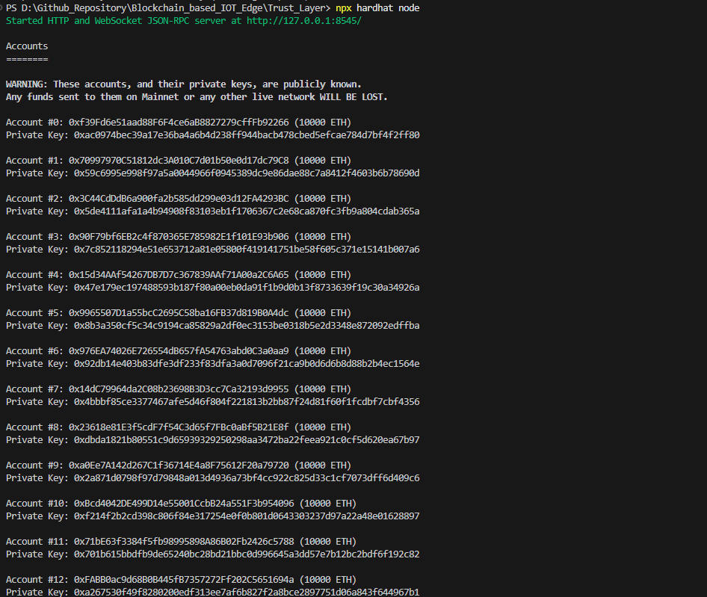
This launches a local Ethereum-compatible blockchain that provides: - Deterministic block mining - Pre-funded test accounts - Stable RPC endpoint (http://127.0.0.1:8545)
Engineering rationale: Hardhat Node replaces Ganache because it: - Is natively aligned with Hardhat artifacts - Avoids RPC instability issues - Provides deterministic account management
The blockchain exists in-memory, but persists while the node is running.

Step 5: Deploy Smart Contract
In a new terminal:
npx hardhat run scripts/deploy.js --network localhost
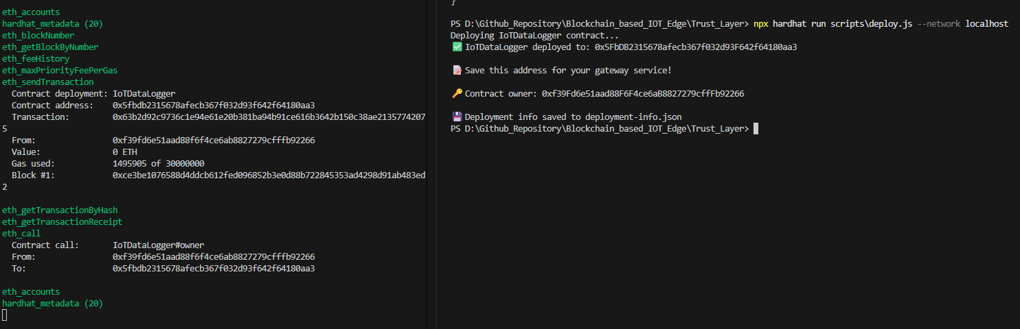
What happens: - Deployment account signs transaction - Contract bytecode is sent to Hardhat node - Contract is mined into a block - A unique contract address is generated
Example output:
IoTDataLogger deployed to: <DEPLOYED_CONTRACT_ADDRESS>
Contract owner: <DEPLOYER_ADDRESS>
This address is the only authoritative reference to the deployed contract.

Step 6: Extract and Distribute ABI
Copy ABI file:
artifacts/contracts/IoTDataLogger.sol/IoTDataLogger.json
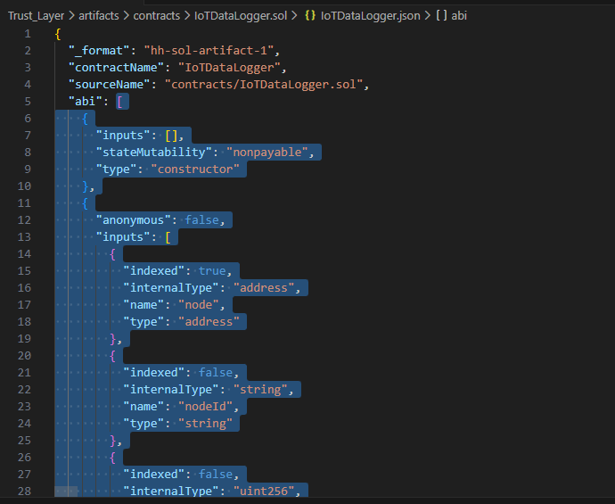
Copy only the abi section into: - iot-gateway/contract-abi.json - web-dashboard/src/utils/contractABI.json
Why this step is explicit: This enforces interface consistency across backend and frontend. ABI mismatch errors occur when this step is skipped or stale files are used.

Step 7: Configure Gateway Environment
Edit iot-gateway/.env:
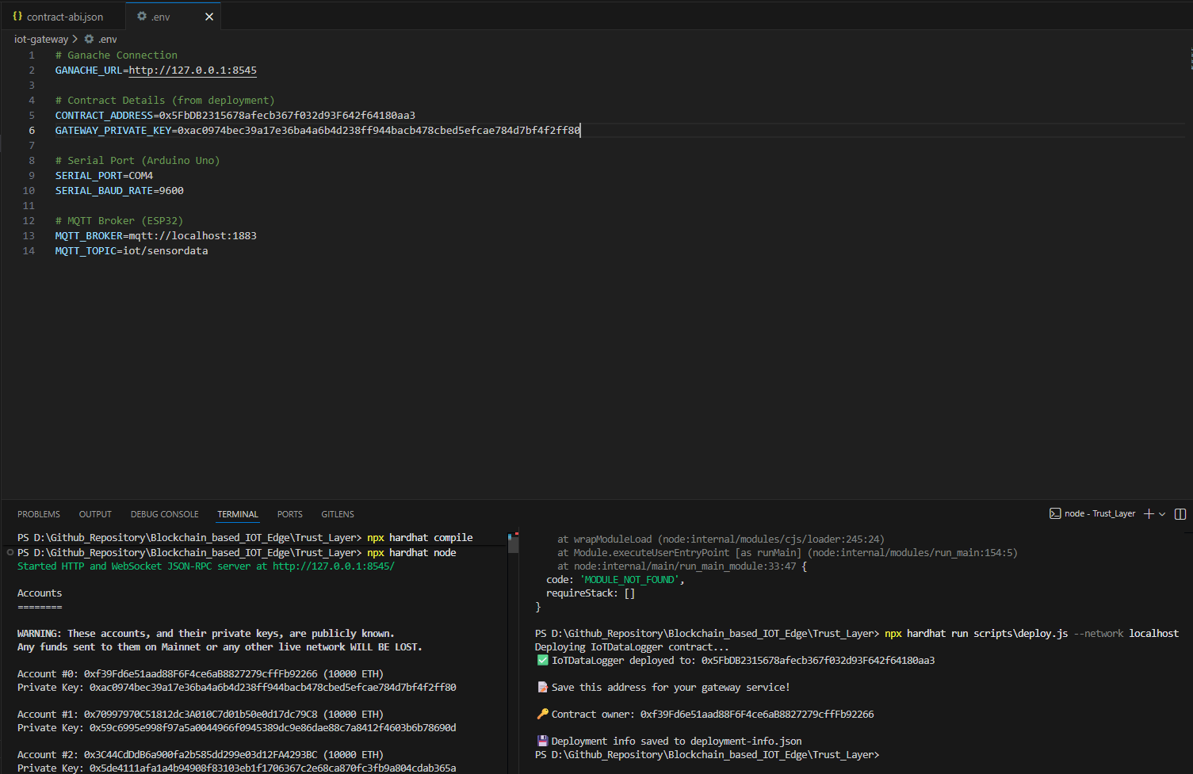
RPC_URL=http://127.0.0.1:8545
PRIVATE_KEY=<DEPLOYER_PRIVATE_KEY>
CONTRACT_ADDRESS=<DEPLOYED_CONTRACT_ADDRESS>
MQTT_BROKER=localhost
MQTT_PORT=1883
Design reasoning: - Gateway owns the signing key - Devices and dashboard never access private keys - All blockchain authority is centralized at the edge

Step 8: Configure Dashboard Web3 Binding
Edit web-dashboard/src/utils/web3Config.js:
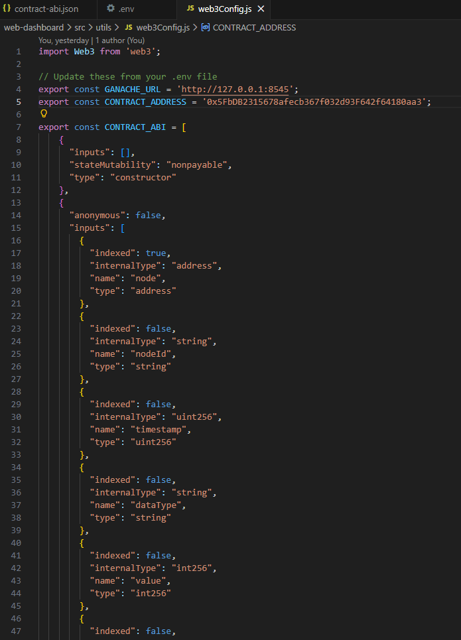
- Set RPC provider to Hardhat node
- Set deployed contract address
- Import correct ABI
Purpose: The dashboard is a read-only blockchain client, used only to visualize on-chain state and events.

Step 9: Start MQTT Broker with custom made mosquito.conf file to allow anonymous users to communication through firewall which the default routine does not
mosquito -c mosquitto.conf -v
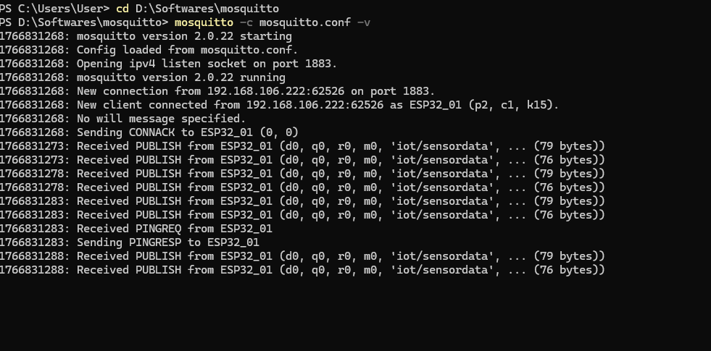
This enables device-to-gateway communication.

Step 10: Start Edge Gateway
cd iot-gateway
npm install
node gateway.js
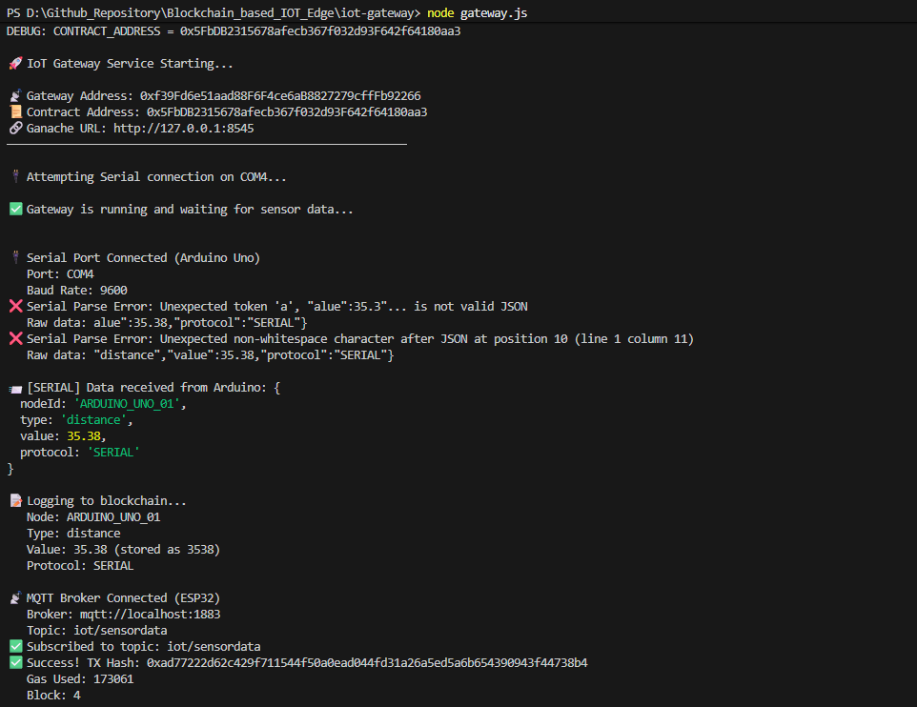
Runtime behavior: - Subscribes to MQTT topics - Validates payload structure - Applies rate limiting and nonce checks - Submits blockchain transactions

Step 11: Flash MCU Firmware
MCU publishes structured JSON payloads via MQTT.
Key principle: Devices are intentionally blockchain-unaware.

Step 12: Start React Dashboard
cd web-dashboard
npm install
npm start
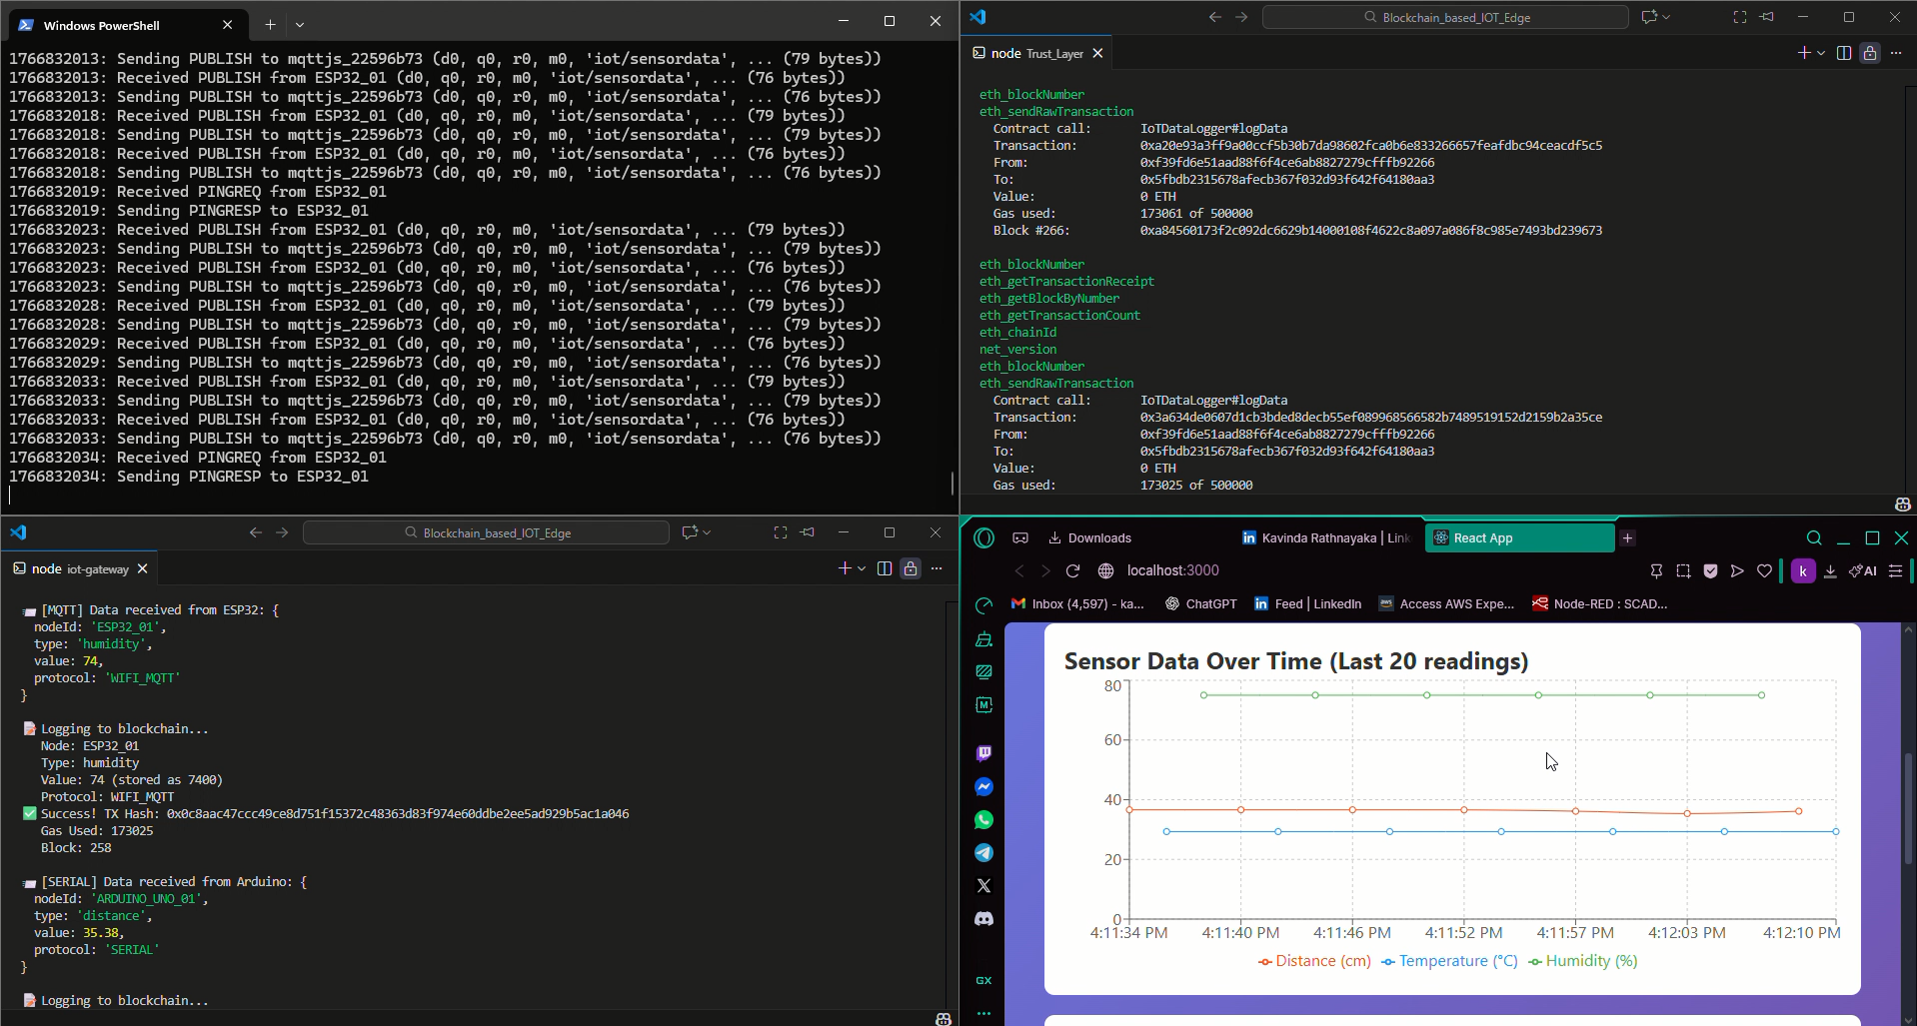
Dashboard connects to: - Hardhat RPC - Deployed contract
Live blockchain events are visualized in real time.

8. End-to-End Data Flow (What Really Happens)
- Device publishes MQTT message
- Gateway receives payload
- Payload validated
- Hash computed
- Blockchain transaction sent
- Smart contract emits event
- Frontend detects event
- User sees confirmation
No step bypasses validation.

9. Failure Modes & Engineering Safeguards
Failure | Mitigation
MQTT flood | Rate limiting
Replay attack | Nonce tracking
Blockchain delay | Async queue
Device spoofing | ID whitelisting

10. Design Limitations (Explicitly Acknowledged)
- Not optimized for high throughput
- Local blockchain only
- No hardware secure element
These are conscious engineering tradeoffs, not omissions.

11. Engineering Value Summary
This project demonstrates:
- Edge trust enforcement
- Blockchain integration without hype
- Practical IIoT architecture
- Separation of concerns
- Security-aware design
It is engineering-first, not trend-driven.

12. How This Would Scale in Industry
- Replace Hardhat with private Ethereum / Hyperledger
- Add TLS + cert-based MQTT
- Introduce hardware root-of-trust
- Deploy gateway in containerized edge node

End of Manual

